# Systems Design and Databases (CIS1018-N) TSQL Tutorial 5: Querying Tables with SELECT

## Before You Start

Finish the previous tutorials before attempting this one. Try to complete this set of tasks before your next tutorial.

**Hint:** It is important before start the lab, you should walk-through lecture(s) and demonstration exercises

## Introduction

This session aims to familiarise you with Querying Tables with SELECT Statement.

As a business analyst for Adventure Works, you will be writing reports using corporate databases stored in SQL Server 2019. You can use your set of business requirements for data to write basic T-SQL queries to retrieve the specified data from the databases.

## How to Opening SQL Server Management Studio (SSMS)

1. **Access from local machine/personal PC**  
   To open [**SSMS**](https://docs.microsoft.com/en-us/sql/ssms/quickstarts/ssms-connect-query-sql-server?view=sql-server-ver15), click the new icon on your Desktop or, click on the Windows **Start Menu** and [**SSMS**](https://docs.microsoft.com/en-us/sql/ssms/quickstarts/ssms-connect-query-sql-server?view=sql-server-ver15)start typing in **SQL** or [**SSMS**](https://docs.microsoft.com/en-us/sql/ssms/quickstarts/ssms-connect-query-sql-server?view=sql-server-ver15)or look for the program in the **Microsoft SQL Server Tools** folder.

|  |  |
| --- | --- |
| Click on Start Menu and search for sql or ssms | Then click on the SSMS icon from the retrieved list |
|  |  |

For convenience, you may choose to right-click the program and pin it to the Start menu and/or pin it to the taskbar, so it is easier to find.

1. **Access through AppsAnywhere**  
   To open SSMS using Appsanywhere within TU campus, click on Appsanywhere icon or type <https://appsanywhere.tees.ac.uk/> in Brower [1]. It will launch the following page of your AppsAnywhere, where you can search for SQL Server Management Studio [2] and click on Launch button [3] as follows:

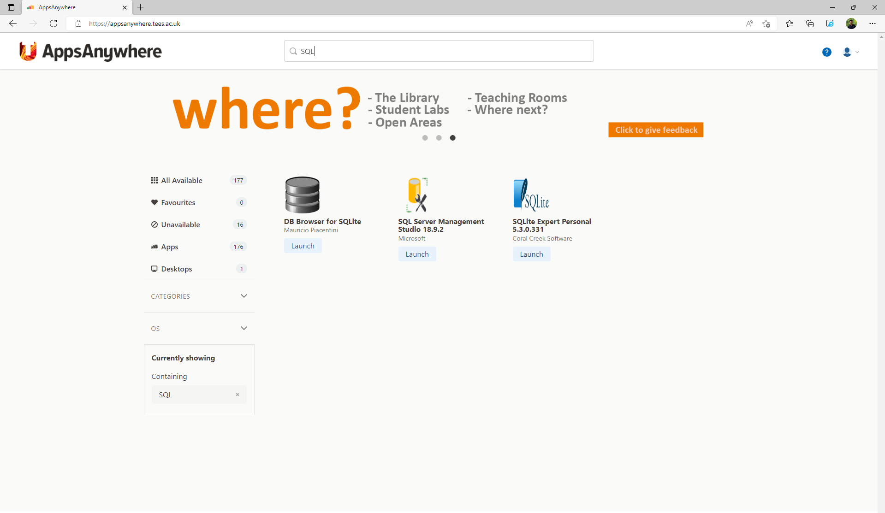

3

1

2

## Connect to SQL Server 2019 using SSMS

**Logon Information:**

* SQL Server Instance is the Lab PC name [or number]
* Use [windows authentication]

**Demonstration Steps:**

* Start SQL Server Management Studio and connect to SQL Server 2019 engine instance using Windows authentication.
* Unzip the Lab/Demo files on local machine (i.e., folder D:\SDD\Week5 folder). This includes all the Demo, Exercises and Solution files with a .SQL extension. (All SQL files can also be opened in Notepad)
* Double Click the appropriate SQL file and it should load automatically in the Query Window. Otherwise open in Notepad and copy and past into the Query Window.
* Make sure you click on the correct SQL Server Database in the Object Explorer

**Explore Database and Other Objects**

* In Object Explorer, expand the Databases folder to see a list of databases.
* Expand the SQL Server Databases
* Work with given SQL Scripts (or the appropriate SQL Server Database Sample)
* If the Solution Explorer pane is not visible, on the View menu, click Solution Explorer.
* In Solution Explorer, notice it is empty.

## Writing Basic SELECT Statements

As a business analyst for Adventure Works, you will be writing reports using corporate databases stored in SQL Server 2019. You can use your set of business requirements for data to write basic T-SQL queries to retrieve the specified data from the databases.

* Exercise 1: Writing Simple SELECT Statements
* Exercise 2: Eliminating Duplicates Using DISTINCT
* Exercise 3: Using Table and Column Aliases
* Exercise 4: Using a Simple CASE Expression

## Exercise 1: Writing Simple SELECT Statement

**Scenario:** As a business analyst, you want a better understanding of your corporate data. Usually, the best approach for an initial project is to get an overview of the main tables and columns, so you can better understand different business requirements. After an initial overview, you will provide a report for the marketing department, whose staff want to send invitation letters for a new campaign. You will ***use the TSQL sample database***.

* Write a SELECT statement that will return all rows and all columns from the Sales.Customers table.

|  |
| --- |
| -- Insert Query here |
| USE TSQL; |

|  |
| --- |
| **Possible Result of Query** |
| … |

## Exercise 2: Eliminating Duplicates Using DISTINCT

**Scenario:** After supplying the marketing department with a list of all customers for a new campaign, you are asked to provide a list of all the countries that the customers come from.

* Write a SELECT statement that Eliminating Duplicates with DISTINCT clause

from the Sales.Customers table.

|  |
| --- |
| -- Insert Query here |
| USE TSQL; |

|  |
| --- |
| **Possible Result of Query** |
|  |

## Exercise 3: Using Table and Column Aliases

**Scenario:** After receiving the initial list of customers, the marketing department would like to have column titles that are more readable and a list of all products in the TSQL database.

* Write a SELECT statement that Using Column and Table Aliases from the Sales.Customers and Production.Products tables.

|  |
| --- |
| -- Insert Query here |
| USE TSQL; |

|  |
| --- |
| **Possible Result of Query** |
| Sales.Customers  …  Production.Products    … |

## Exercise 4: Using a Simple CASE Expression

**Scenario:** Your company has a long list of products and the members of the marketing department would like to have product category information in their reports. They have supplied you with a document containing the following mapping between the product category IDs and their names:

**Categoryid categoryname**

1 Beverages

2 Condiments

3 Confections

4 Dairy Products

5 Grains/Cereals

6 Meat/Poultry

7 Produce

8 Seafood

They have an active marketing campaign for categorid (1, 7, 8), and would like to include product category information in their reports.

Learn more about SQL Case Expression: <https://www.w3schools.com/sql/sql_case.asp>

* Write a SELECT statement that Using a Simple CASE Expression from the Production.Products table.

|  |
| --- |
| -- Insert Query here |
| USE TSQL; |

|  |
| --- |
| **Possible Result of Query** |
| … |

## Document History

Prepared by Dr Yar Muhammad,   
Revision 0. (22-Aug-22): This is the initial version of the 2022/23 exercise.